**Phone Book Using**

**Swing GUI, Array and RMI**

**Java Assignment-1**

**BE in Software Engineering**

**(4th year) Level-8**

**Submitted By:- Deepansh Dubey**

**Student Id- A00268737**

**Athlone Institute Of Technology**

**Ireland**

October 25, 2019

**Brief Specification On Phone Book Application**

**Title of the Project:-** Phone Book Application

**Screen Of Application :-**

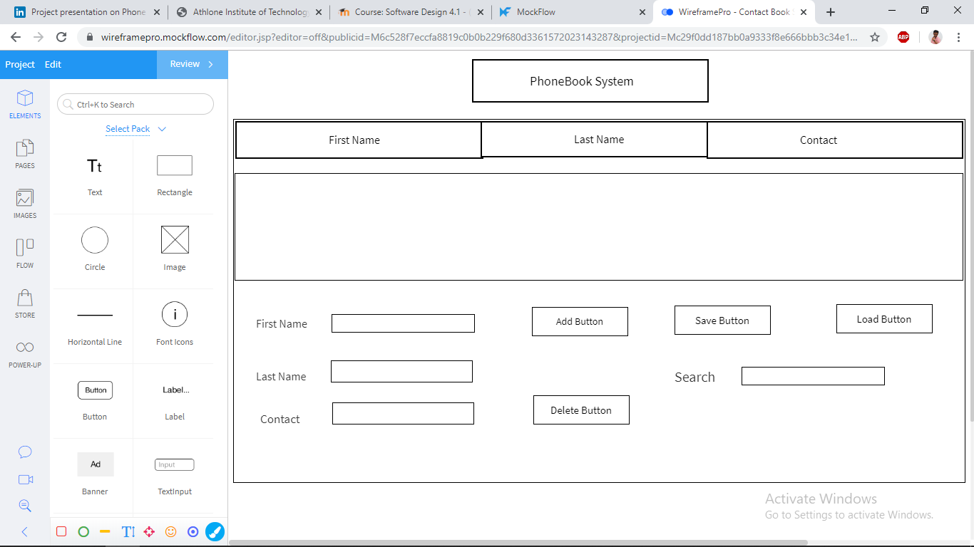

**Objective:-**

This aim of this assignment is to develop the Phone Book using the general need required by the user. The objective of this assignment is to record the details/contact of user. It will simplify the task and reduce the paper work. The system is very user friendly and it is anticipated that applicants will easily access the functions of the system. This will help user to easily search and manage contacts using this system.

**Classes:-**

* **Contact.Java:-**

This class contain the Java code for Phone bookand havingdifferent functionality for the buttonslike

* **Add –** To add the contact in a contact list.
* **Delete –** To delete the particular contact from contactlist.
* **Save -** To save the contact in a contact list as a file format.
* **Search Bar -** To search the contact from the contact list.
* **Load Button –** To load the file to open.
* **Server.java:-**

Server.java file will be having the GUI and action event to call the classes.

* **Client.Java:-**

To use the system as RMI there has to be a client.java file to use system to on their machine.

* **Implement.java:-**

Implement.java file will be having all the calculation in order to find the answer of each functionality.

* **Interface.java:-**

It is very similar to class. It is a collection of abstract methods. A class implements an interface, thereby inheriting the abstract methods of the interface.